**Library Usage Survey Results**

**1. Do you have a library card for the Lincoln Park Public Library?**

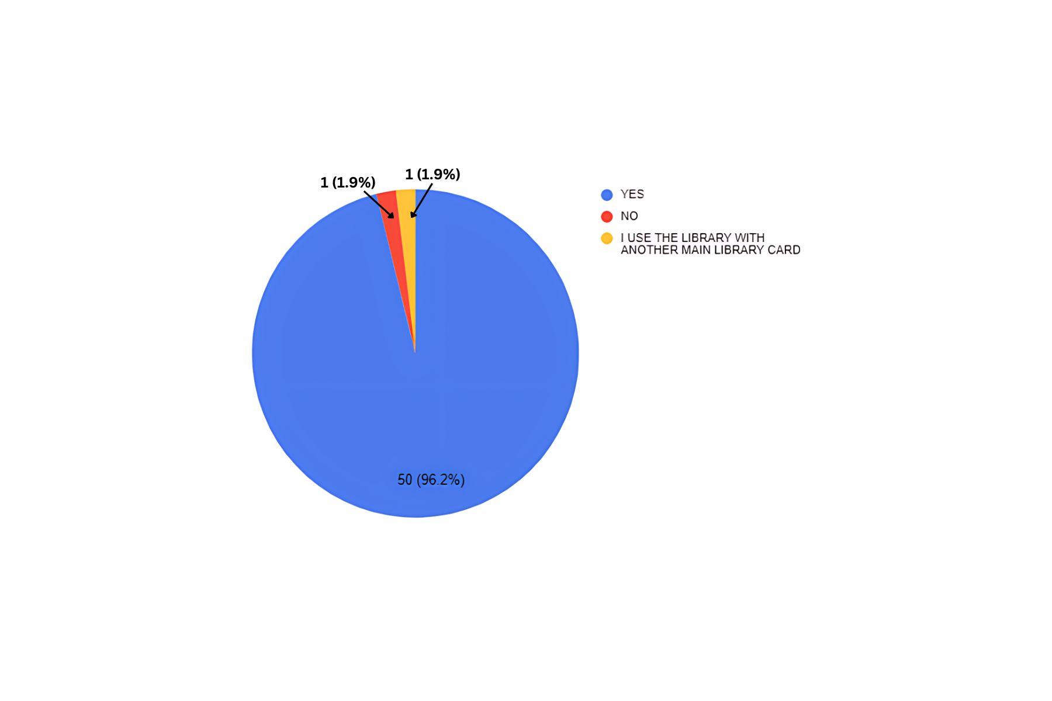

**2. What is your age group?**

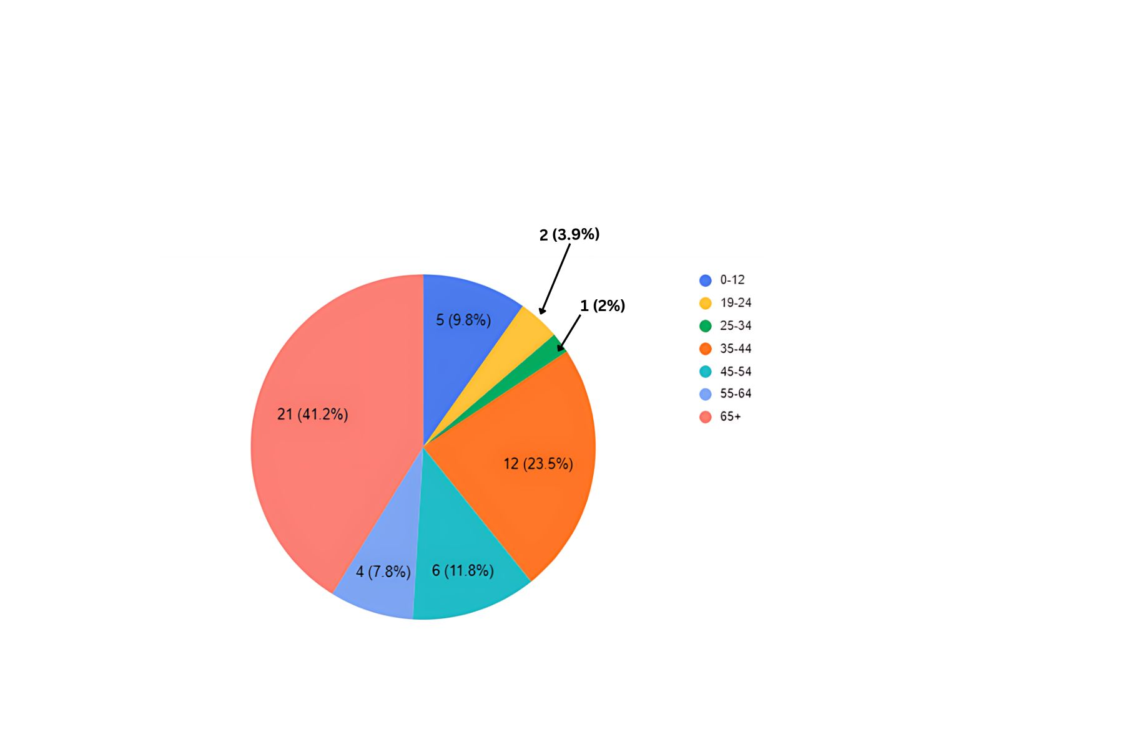

**3. In your opinion, how important is the Lincoln Park Public Library to you and your family?**

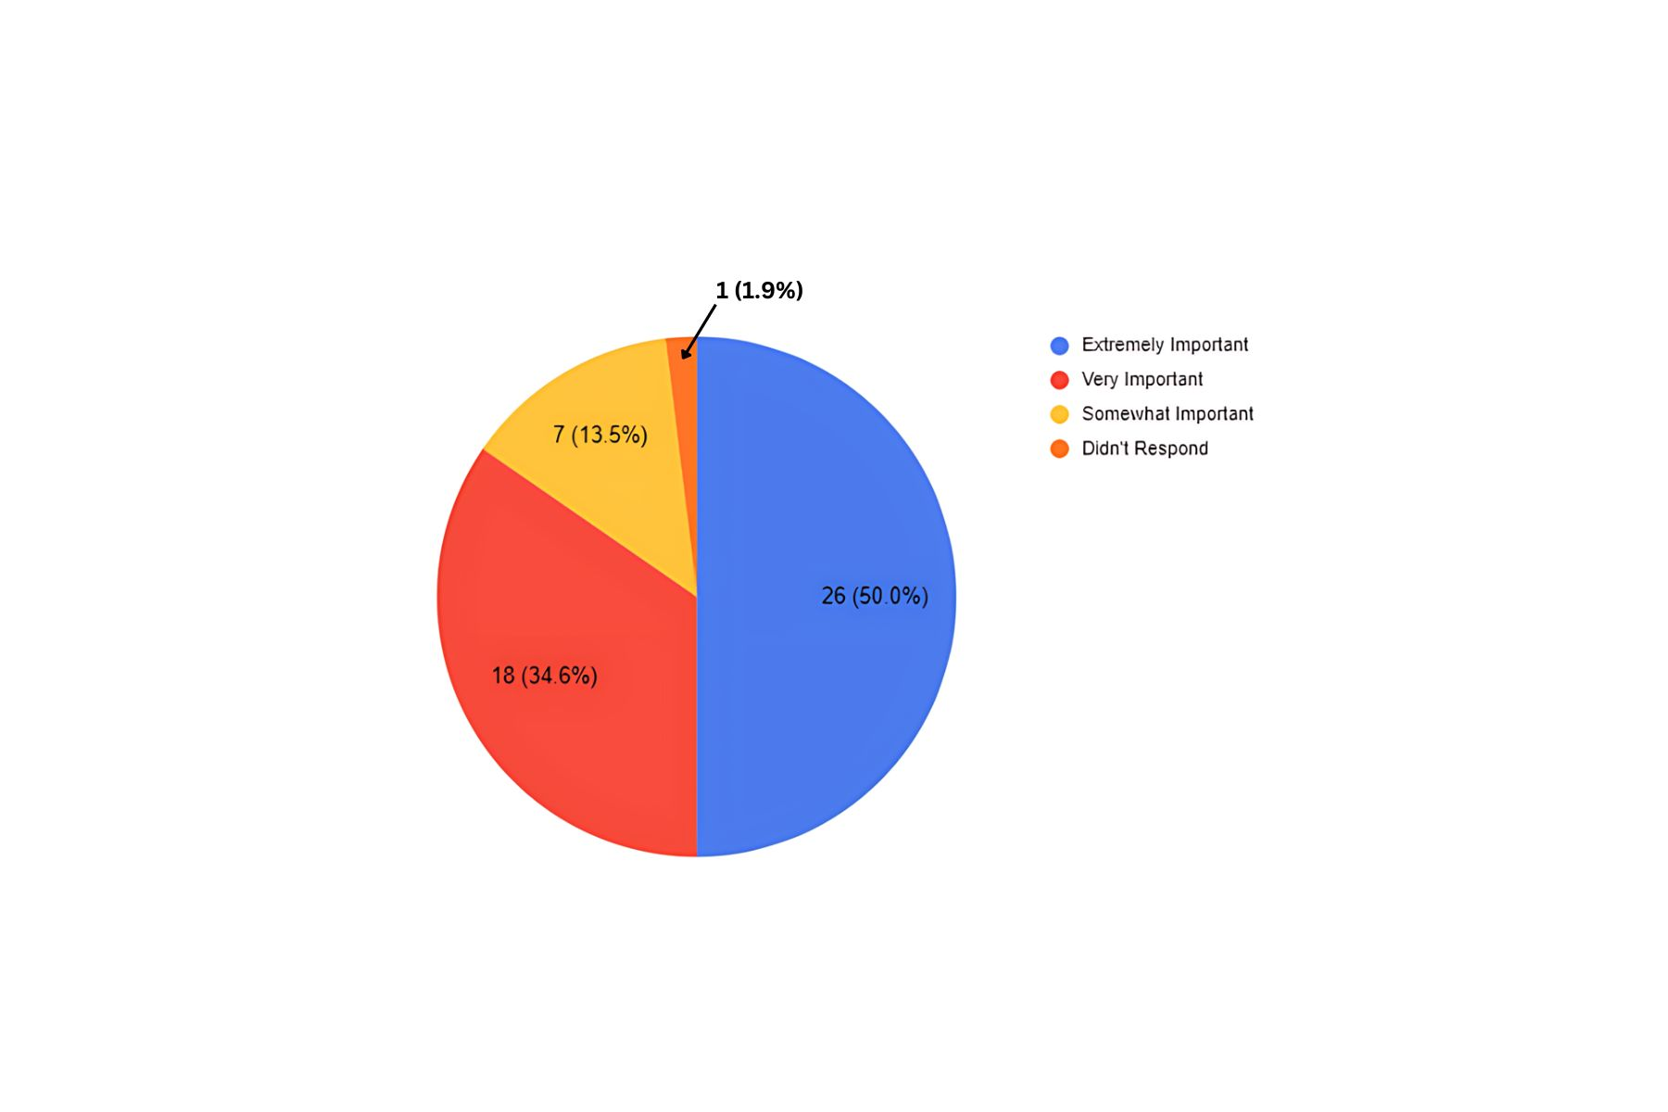

**4. In your opinion, how important is the Lincoln Park Public Library to the town of Lincoln Park?**

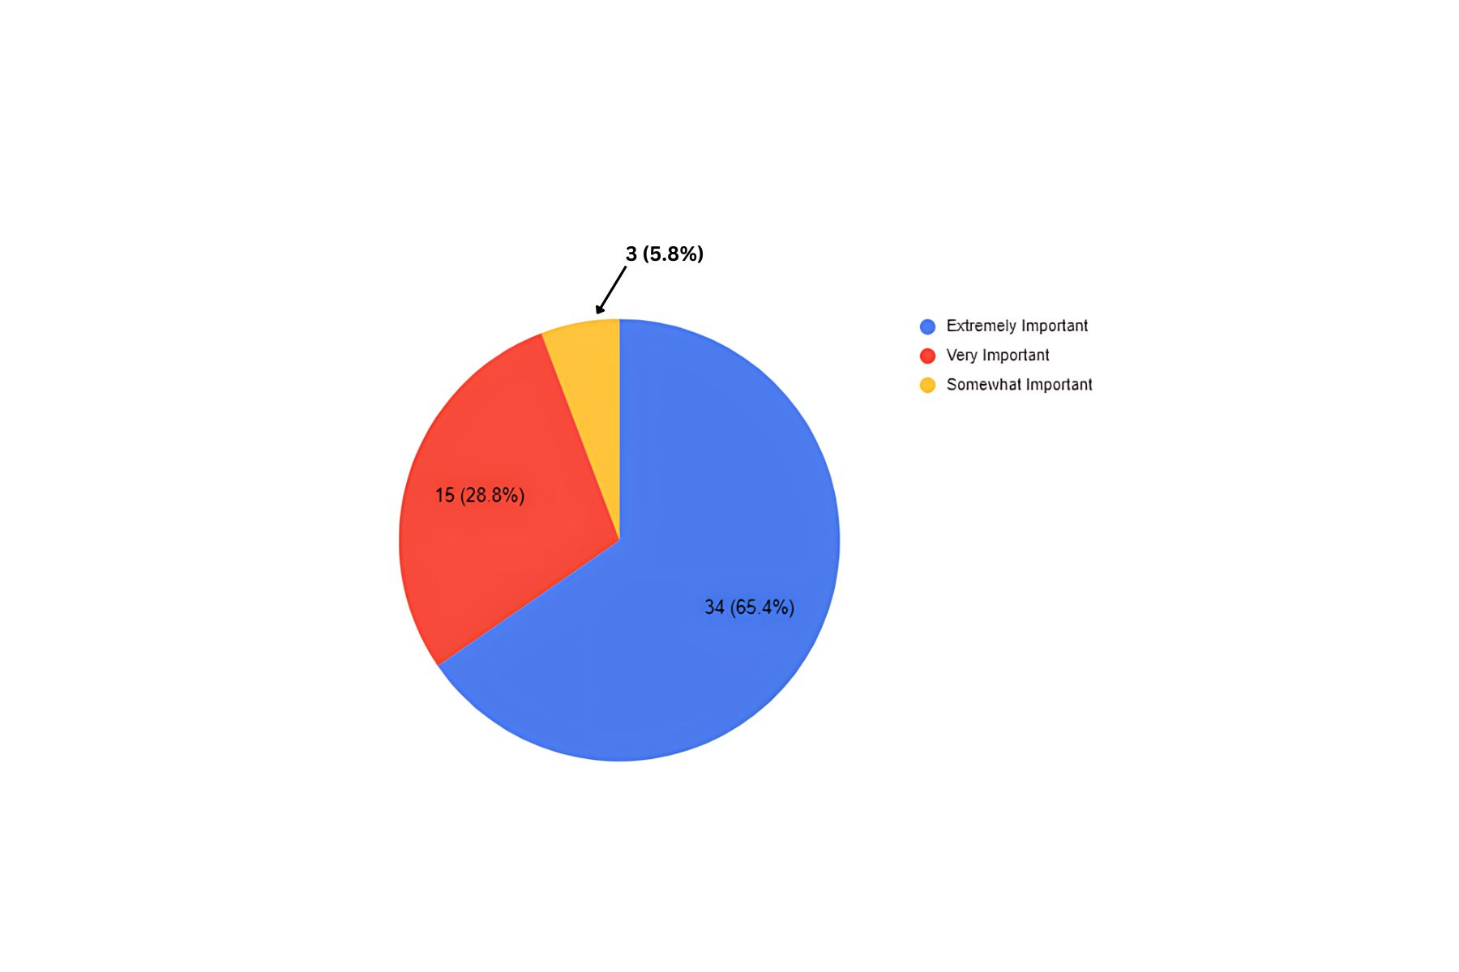

**5. What are the main ways you and/or your family use the Lincoln Park Public Library? Check all that apply.**

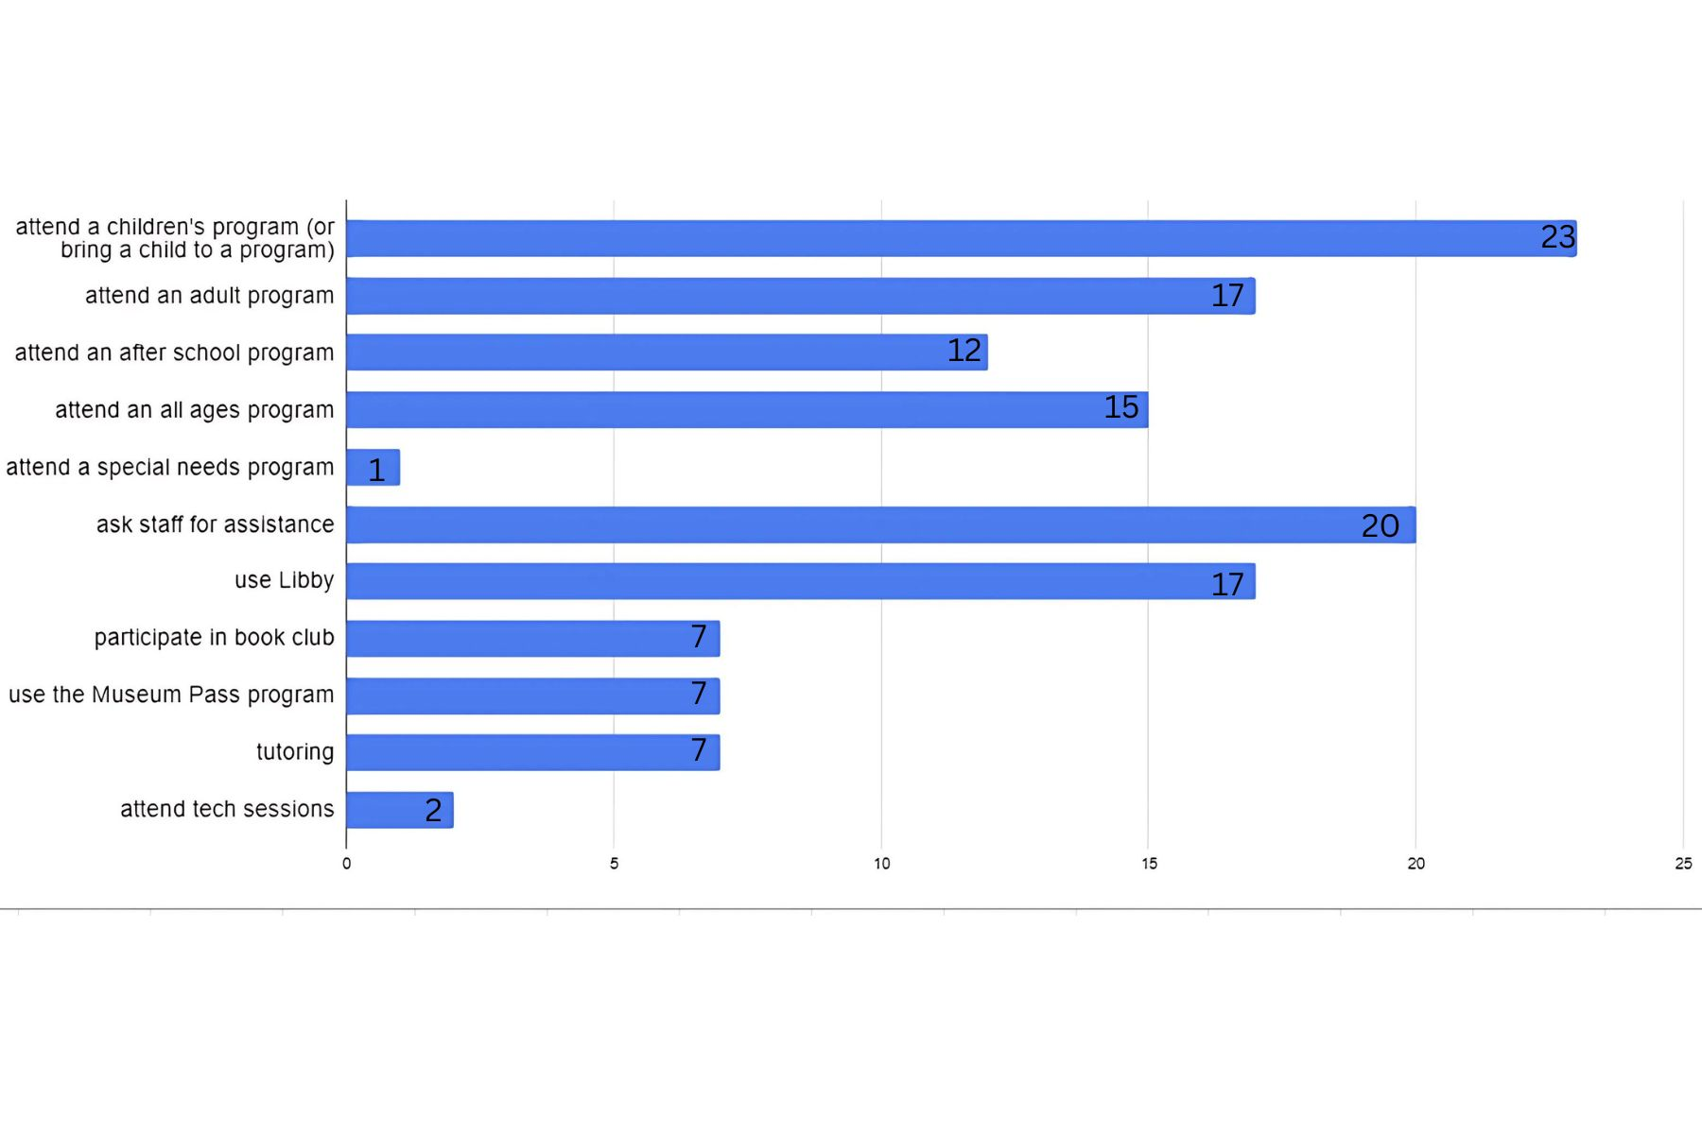

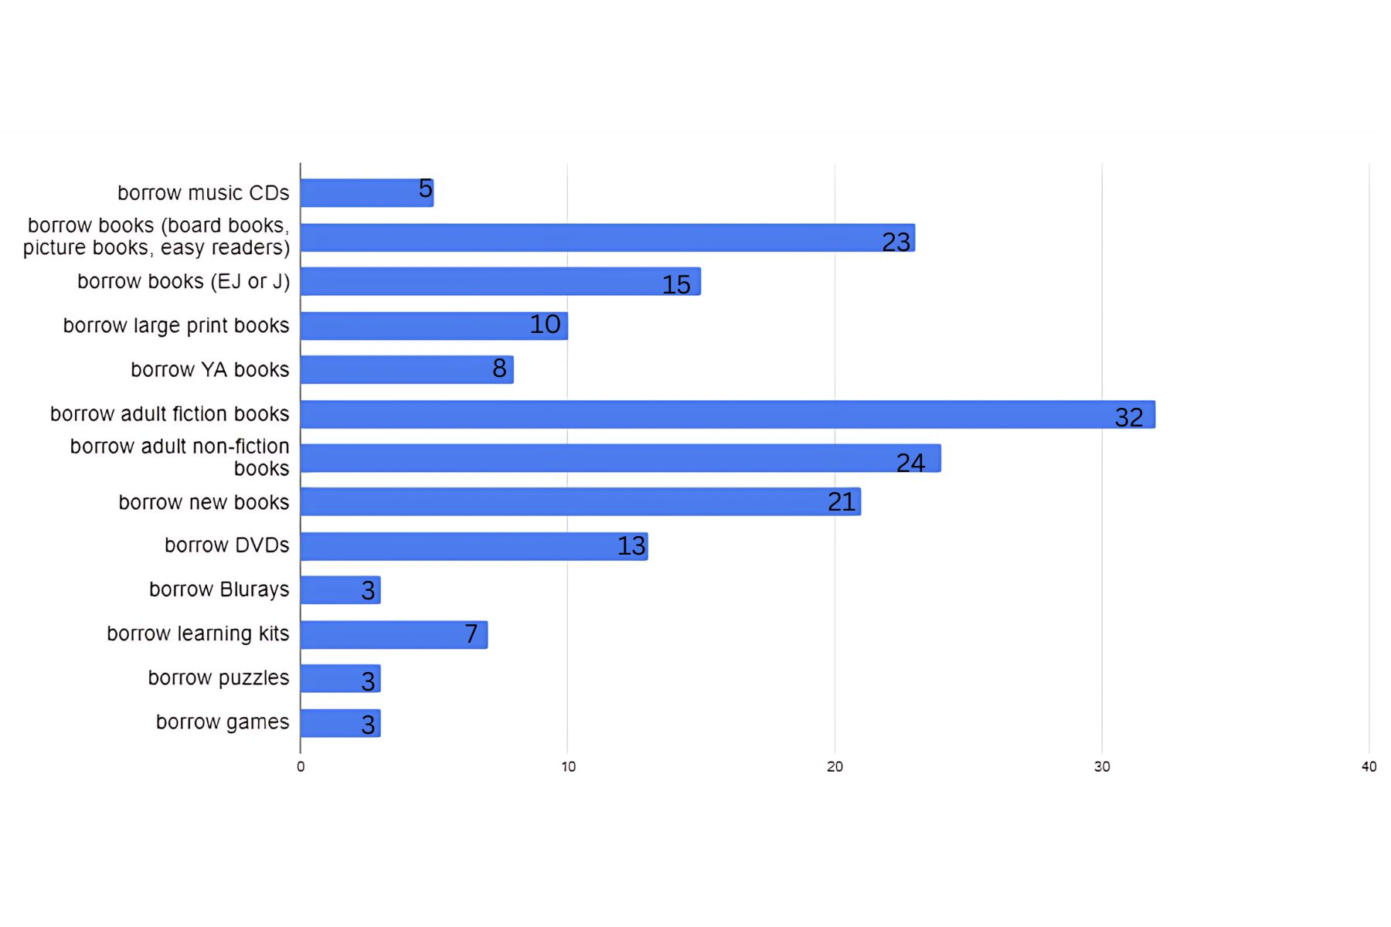

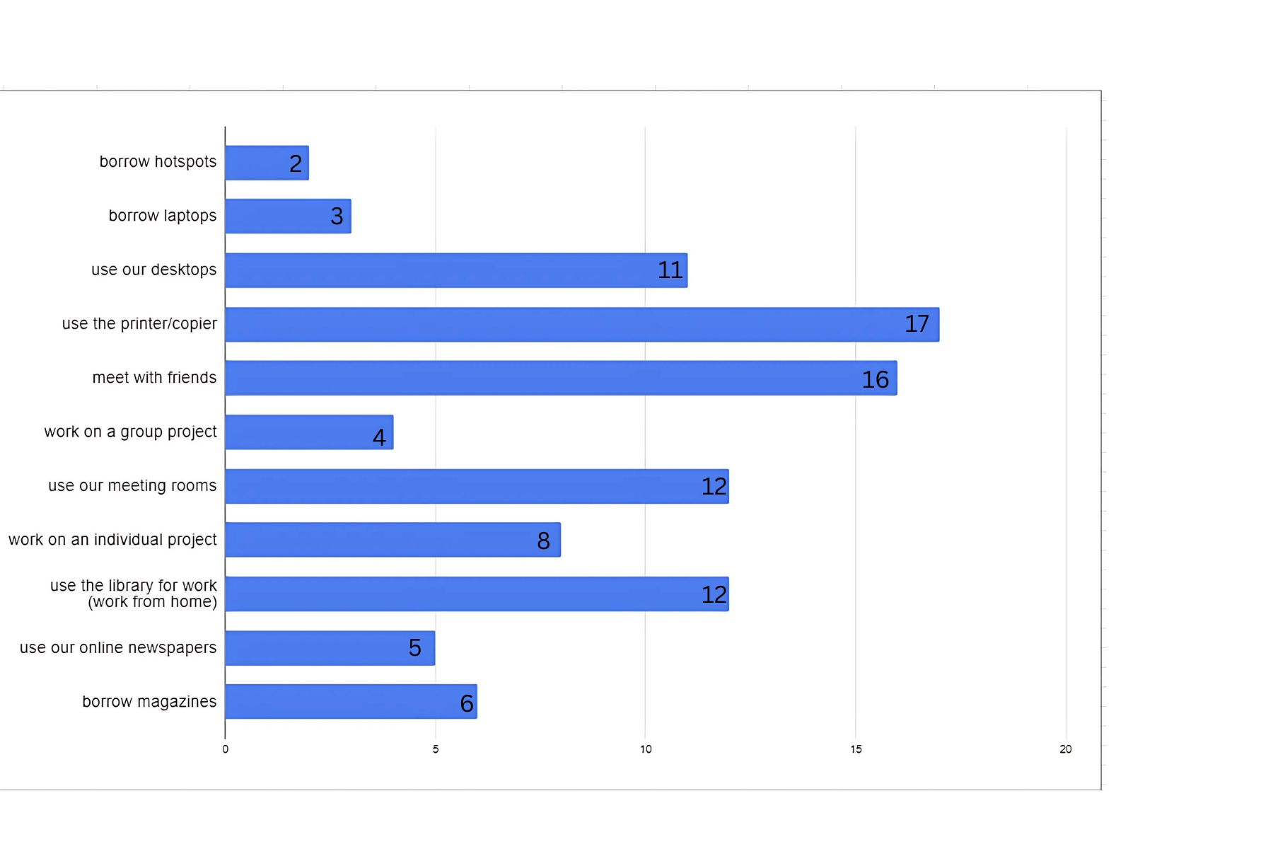

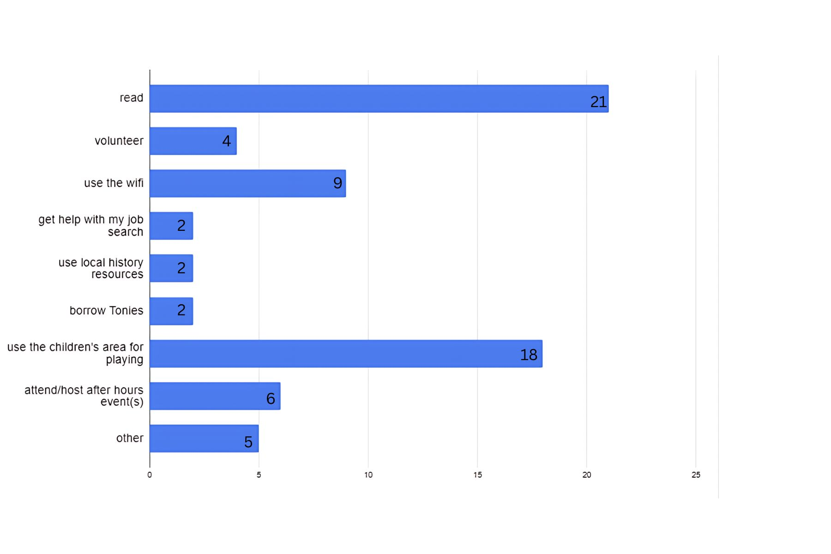

**6.What do you like best about the Lincoln Park Public Library?**

*Categories are grouped to combine similar responses

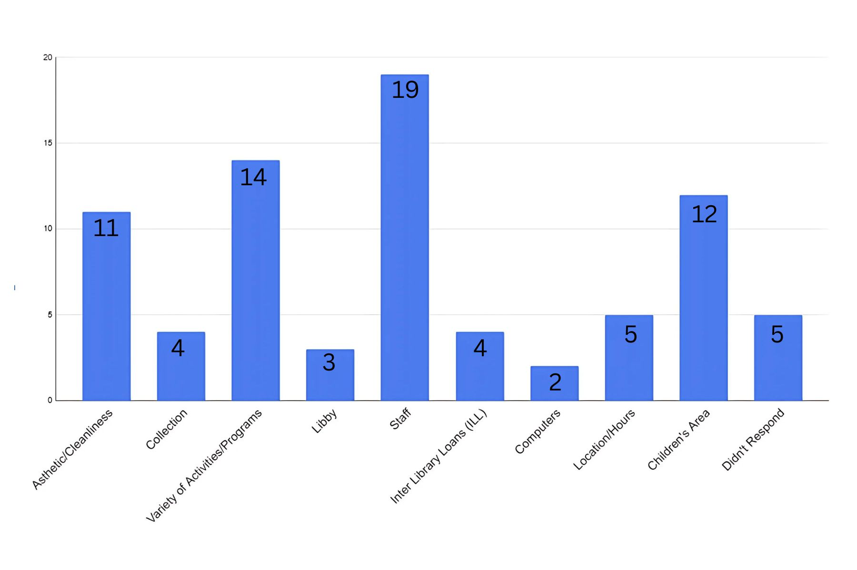

**7. What is the most disappointing thing about the Lincoln Park Public Library?**

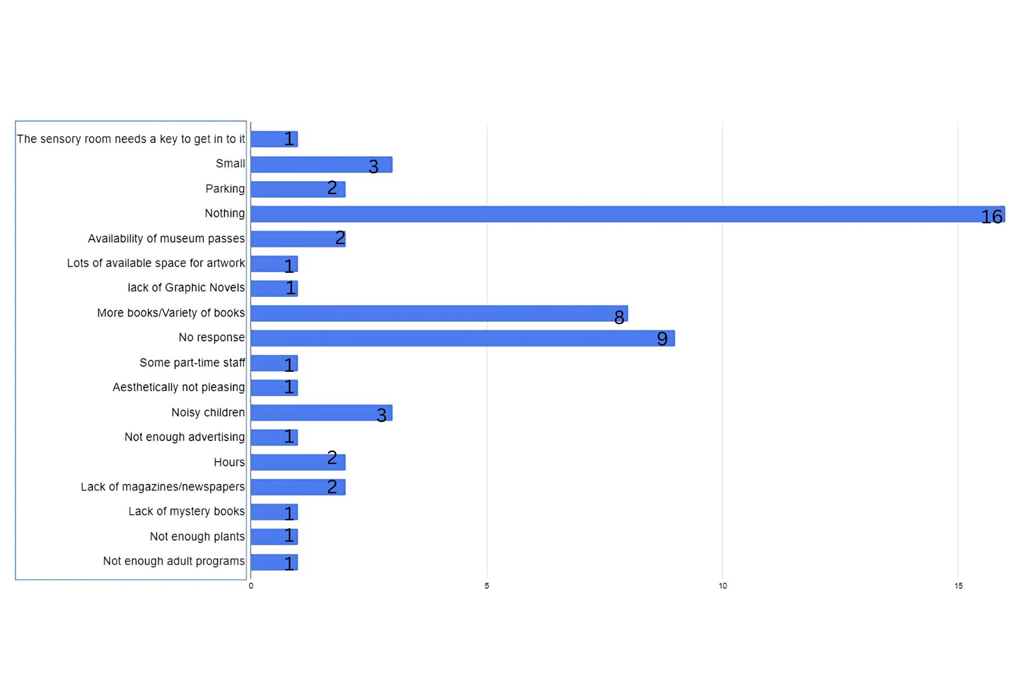

**8. As we continue to improve our building and services, what would you like to see?**

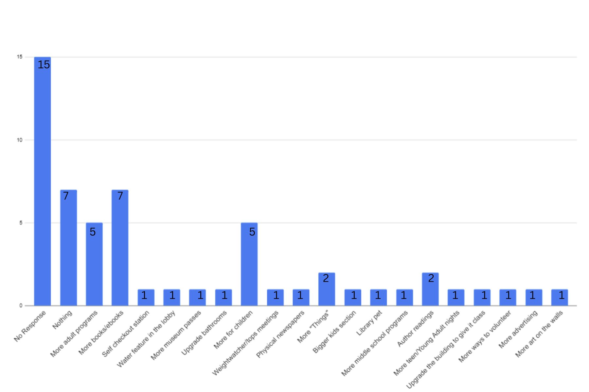

**9. How important is it that the library provide a venue for visual and performing art, literary and musical activities, lectures and author talks?**

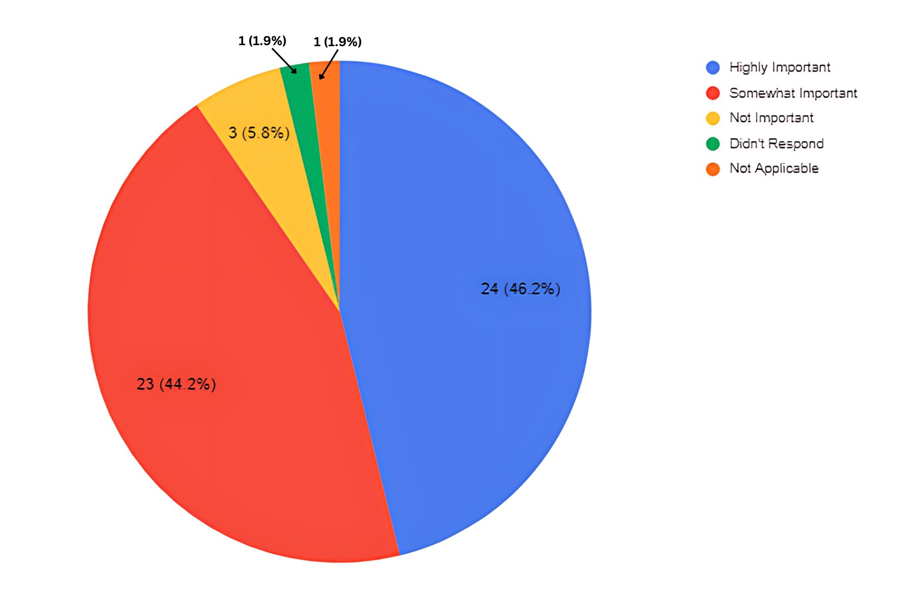

**10. How important is it that the library create a digital tech/media center that connects people through gaming, coding, computing and digital literacy?**

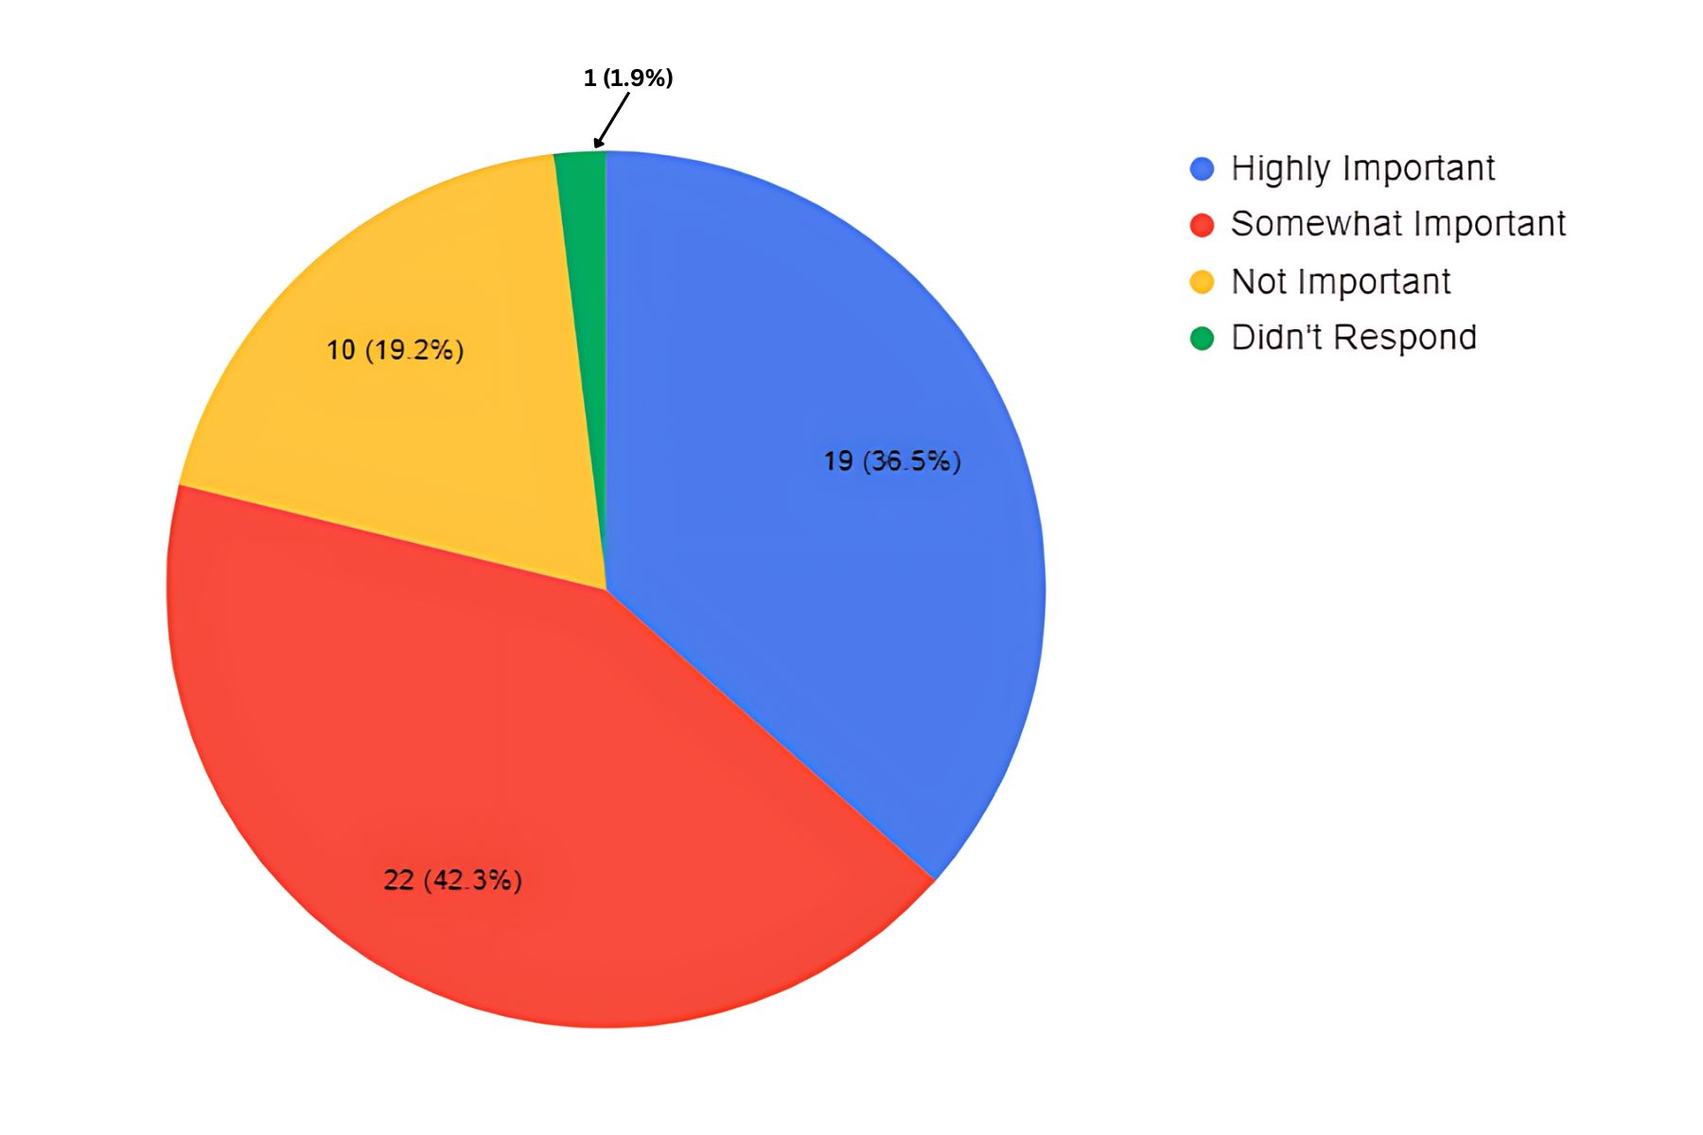

**11. How important is it that the library offer a welcoming and lively public space for the entire community?**

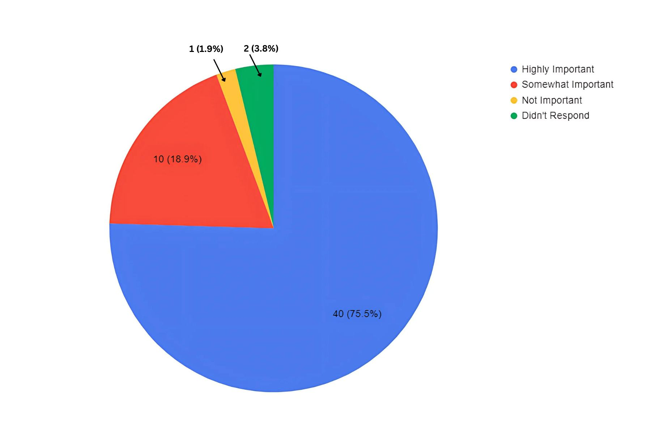

**12. How important is it that the library engage all residents with a spectrum of services and resources that will appeal to all ages?**

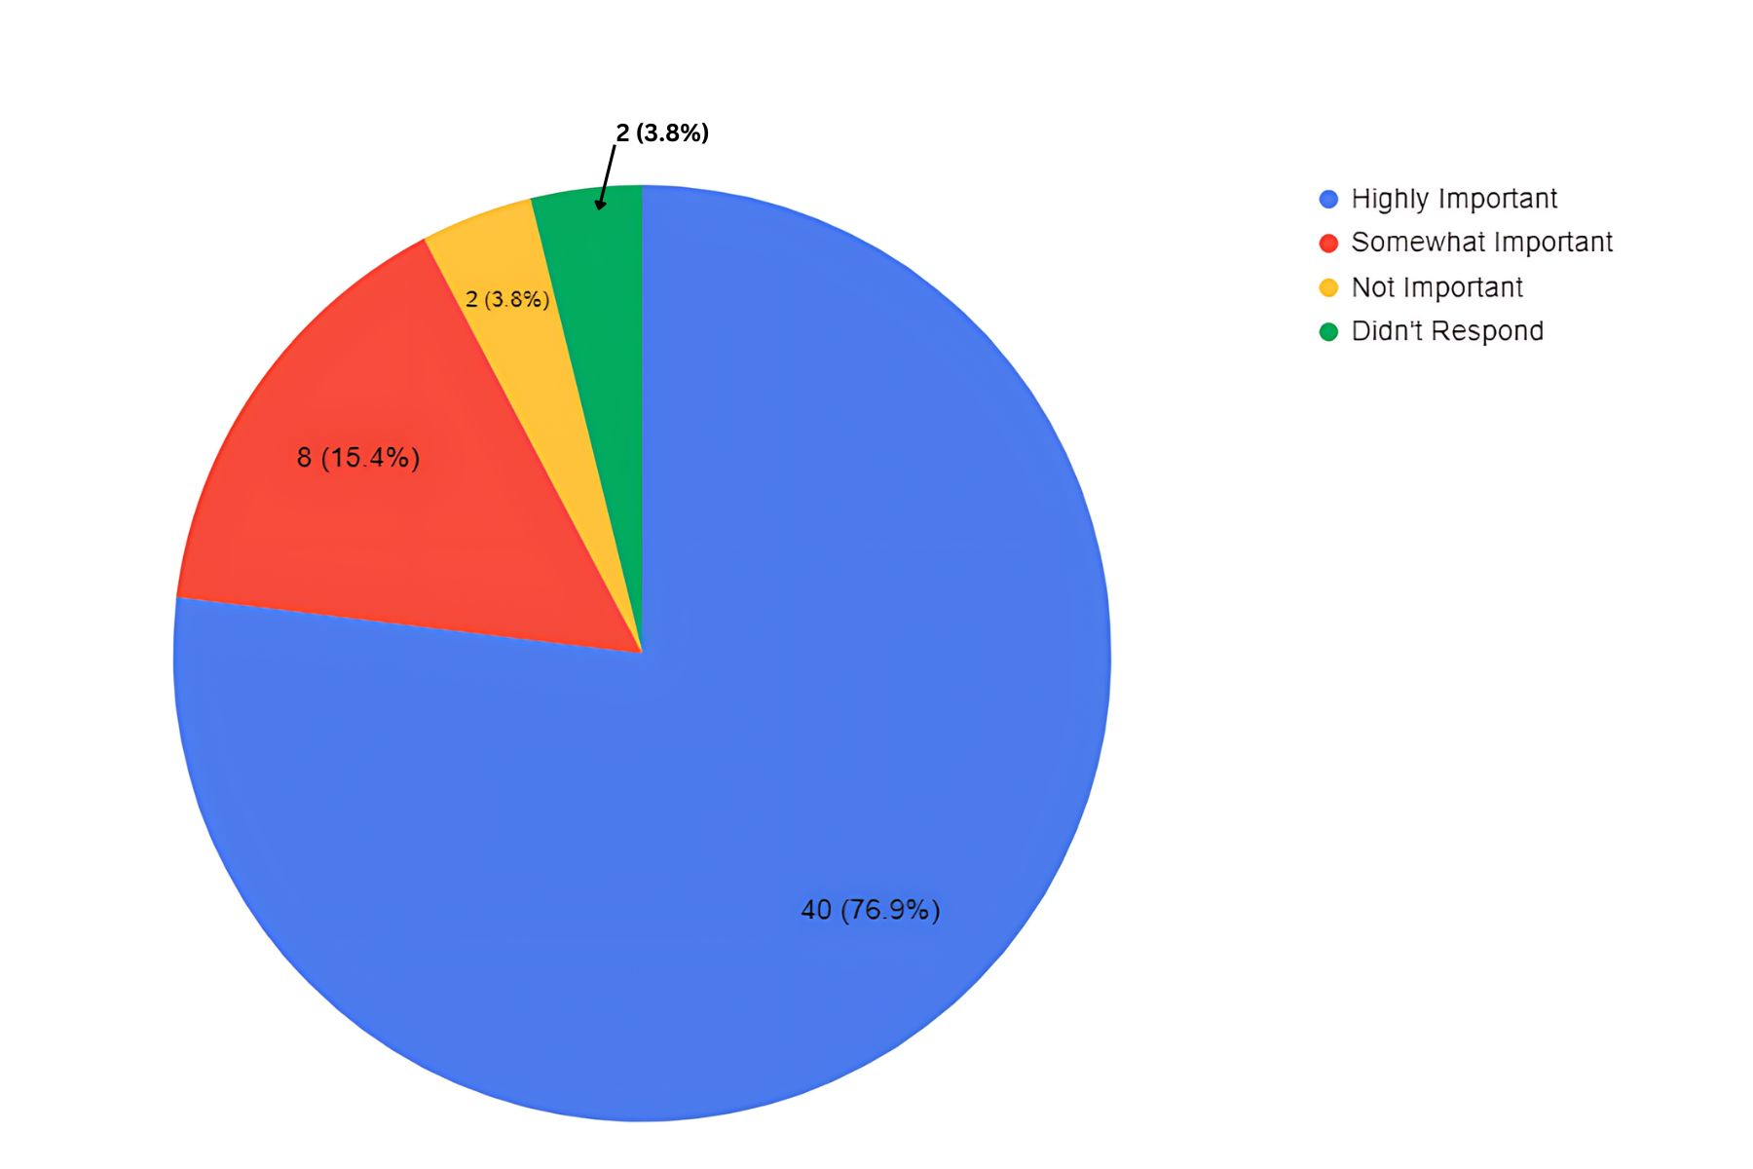

**13. If you do not use the library, what reason(s) most accurately describe why you don't use the library?**

* Too busy/no time (2)
* I buy my own books and other materials
* Check out the appearance of other towns libraries
* I use another library (2)
* Activities I want to participate in are always full
* I don’t like to read
* Unable to concentrate during self study

**14. During a visit to the library, which of the following are the most important to you and your family?**

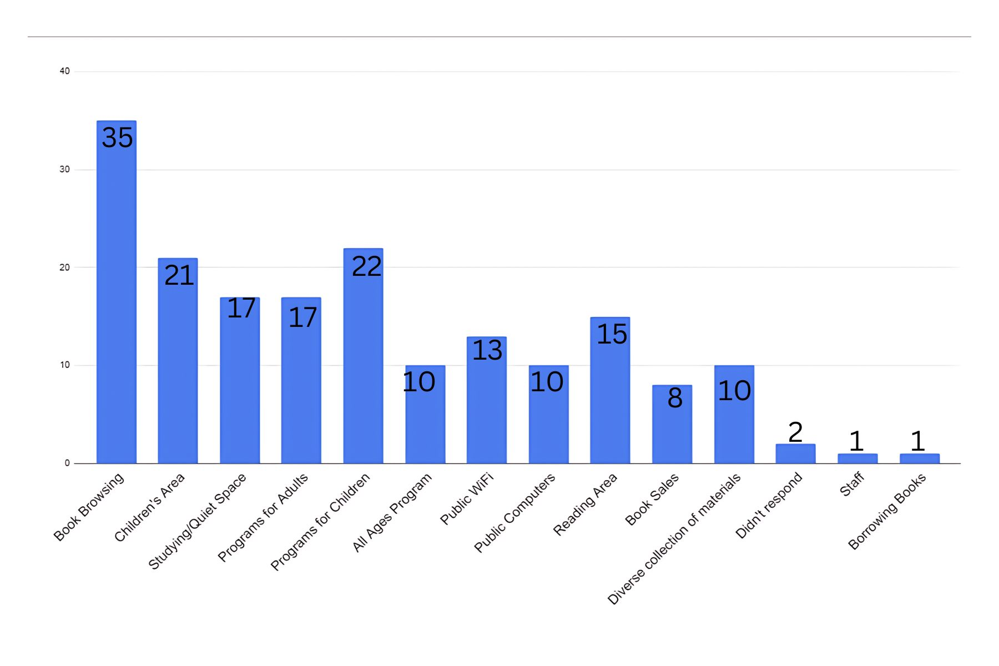

**15. If you have visited the Lincoln Park Public Library since our renovation, please describe how you felt about the facility.**

*Categories are grouped to combine similar responses

| Responses | # OF PEOPLE WHO RESPONDED |
| --- | --- |
| Beautiful/Welcoming | 9 |
| Love it!/ It's great | 14 |
| New Meeting Rooms | 3 |
| Love the new children's area | 4 |
| Improved/looks great/ beautiful | 8 |
| Much better space | 8 |
| Helpful | 1 |
| Not architecturally interesting or attractive | 1 |
| Preferred the old magazine layout better | 1 |
| Decor is great | 1 |
| Wish it had an enclosed children's area | 1 |
| Has a "fresher" feel/ more modern | 3 |
| Cozy/Clean | 3 |
| Facility is too loud/too much like a daycare | 1 |
| Very pleased | 1 |
| Not as welcoming | 1 |
| Love new space. Old space was dark and dingy. | 1 |
| I miss the 202 entrance | 1 |
| There are less book shelves | 1 |
| Less books/ too many games and puzzles I have no interest in | 1 |
| Friendly staff/good selection | 1 |
| No response | 3 |

**16. What if anything could the library do to continue to improve its space?**

| Responses | # OF PEOPLE WHO RESPONDED |
| --- | --- |
| Bigger program room | 1 |
| “In my opinion, the library should not feel like a preschool; the library should not have a permanent or lively space for young kids. Child programs should be relegated to spots on the calendar so as to not to make the library feel like a jungle gym. And the focus should be making the library feel like a mature academic building with lots of literary and DVD choices.” | 1 |
| Nothing | 4 |
| Not sure. The space is adequate and doesn’t seem cluttered. | 1 |
| Private reading rooms | 1 |
| More seating in the kids section | 2 |
| Remove the door on the sensory room | 1 |
| Separate room for kids | 2 |
| More kids books and a book corner | 1 |
| More books | 1 |
| Continue to have friendly/approachable staff | 1 |
| More science and learning activities | 1 |
| Children should be better managed; they are too distracting. | 1 |
| More marketing | 1 |
| Soundproof the programs so that other people don’t hear them | 1 |
| More artwork | 1 |
| Make the program room more kid friendly | 1 |
| No response | 32 |

**17. What if anything could the library do to continue to improve overall?**

| Responses | # OF PEOPLE WHO RESPONDED |
| --- | --- |
| More computer literacy programs | 1 |
| More books and ebooks | 3 |
| Nothing | 8 |
| Should leave space in program registration open specifically for seniors | 1 |
| Increase the size of the library | 1 |
| Continue engaging children | 1 |
| Open on Sunday | 1 |
| More advertising | 1 |
| Make loans from other libraries arrive quicker | 1 |
| Continue with educational activities focusing on STEM | 1 |
| More kids books/bigger kids area | 1 |
| Have a staff member sit at the front desk at all times | 1 |
| More senior events | 1 |
| More hours | 1 |
| Free language classes other than Spanish or Italian | 1 |
| No response | 32 |

**18. What do you value most about the library?**

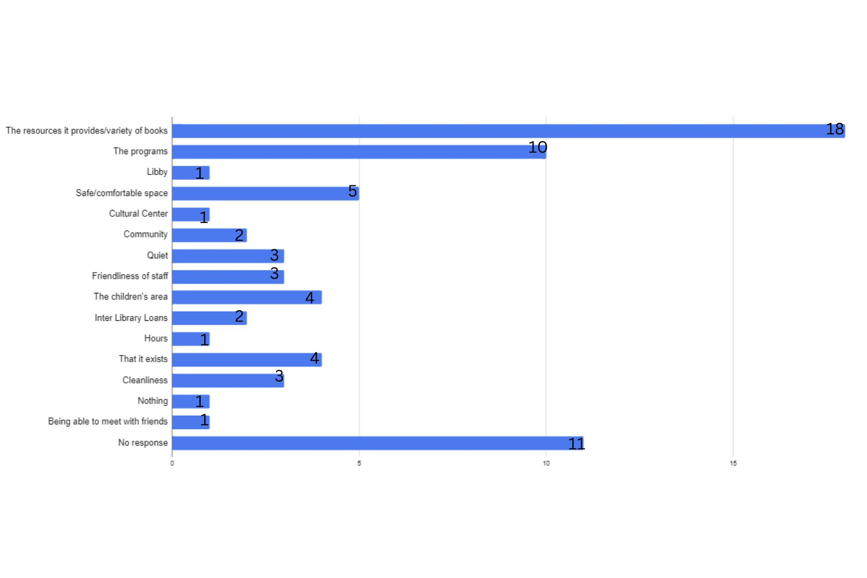

**19. Please pick 3 of the most important library shared values.**

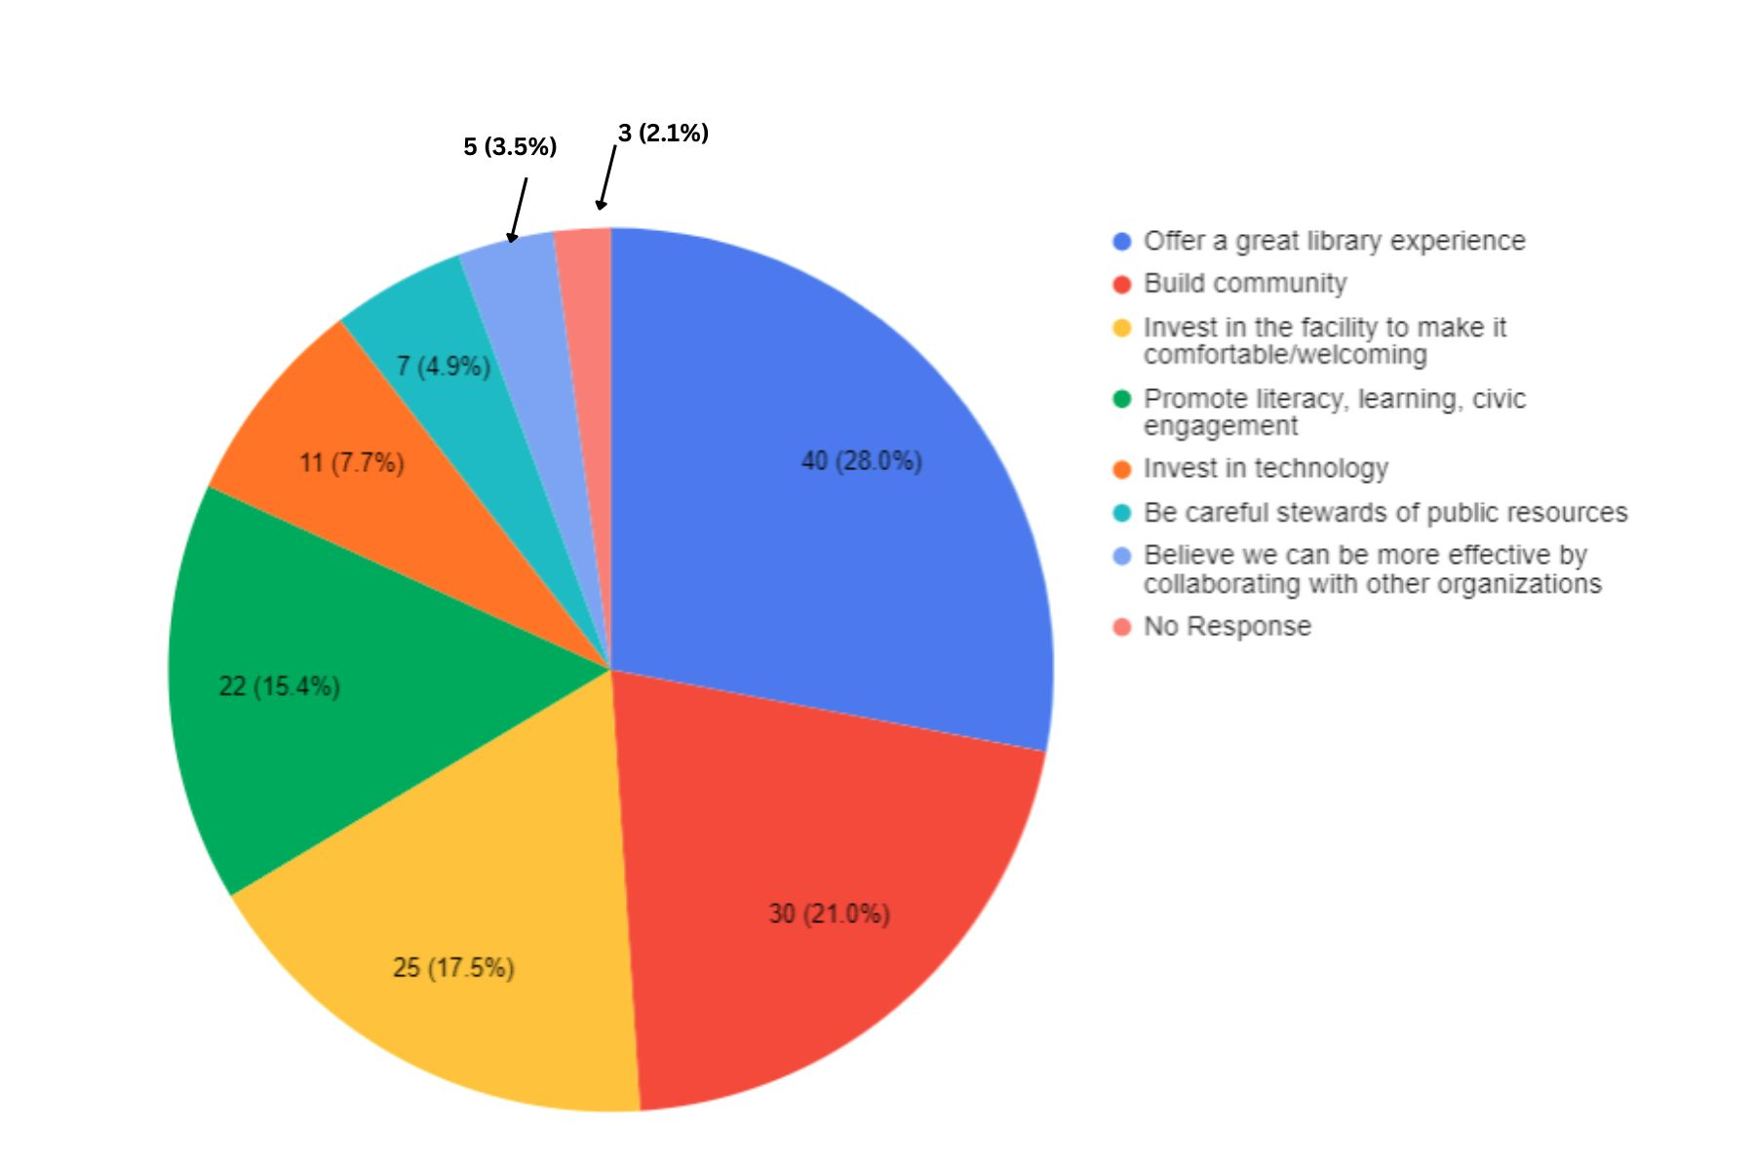

**20. Please pick up to three of the most important library strengths.**

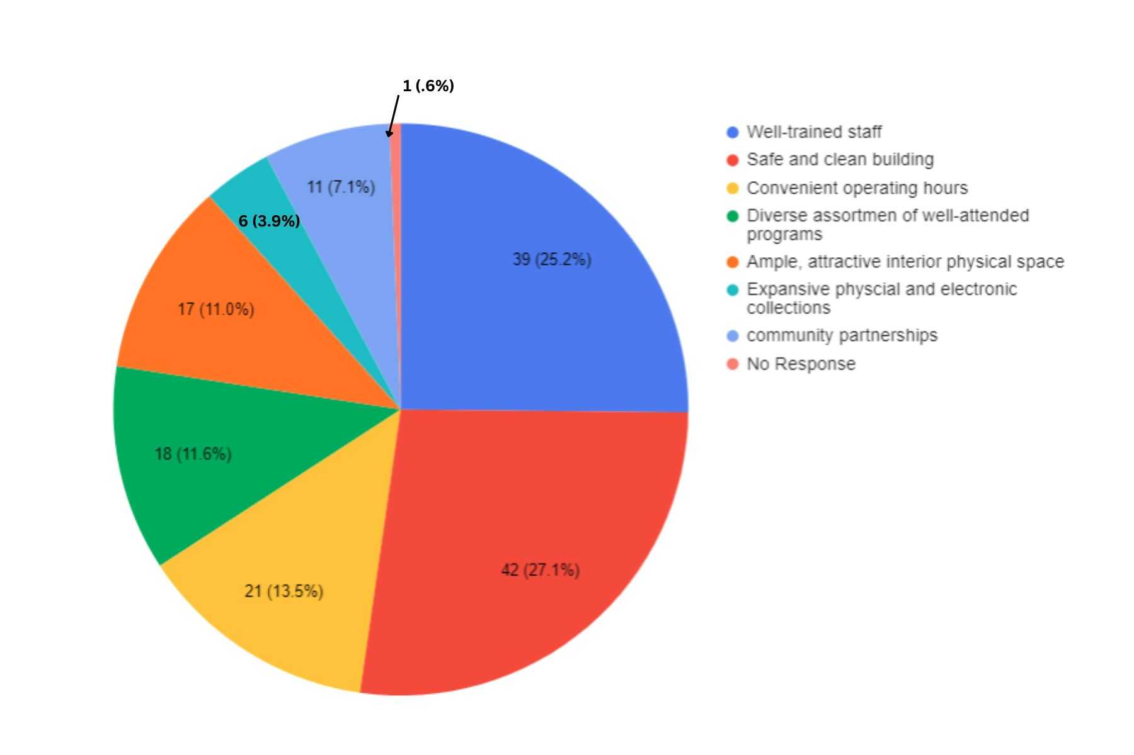

**21. On a scale of 1, with 5 being the best, how would you rate your satisfaction with the Lincoln Park Public Library?**

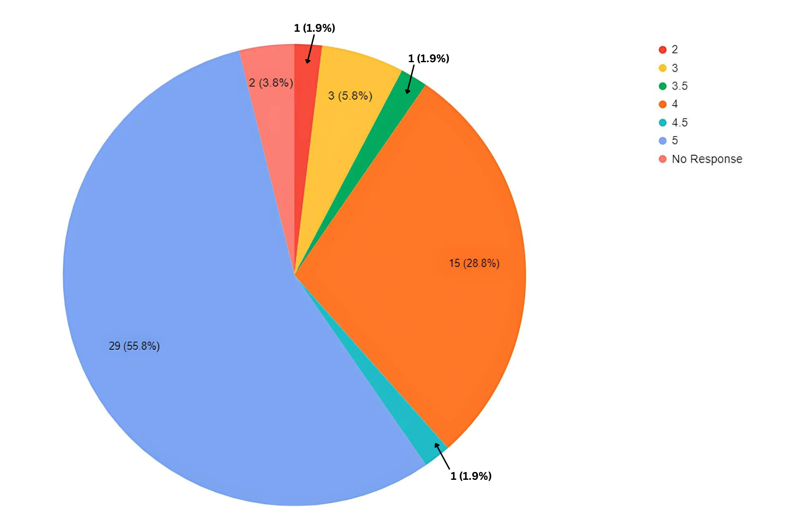

**22. In a sentence or more, please describe what type of community you want Lincoln Park to be.**

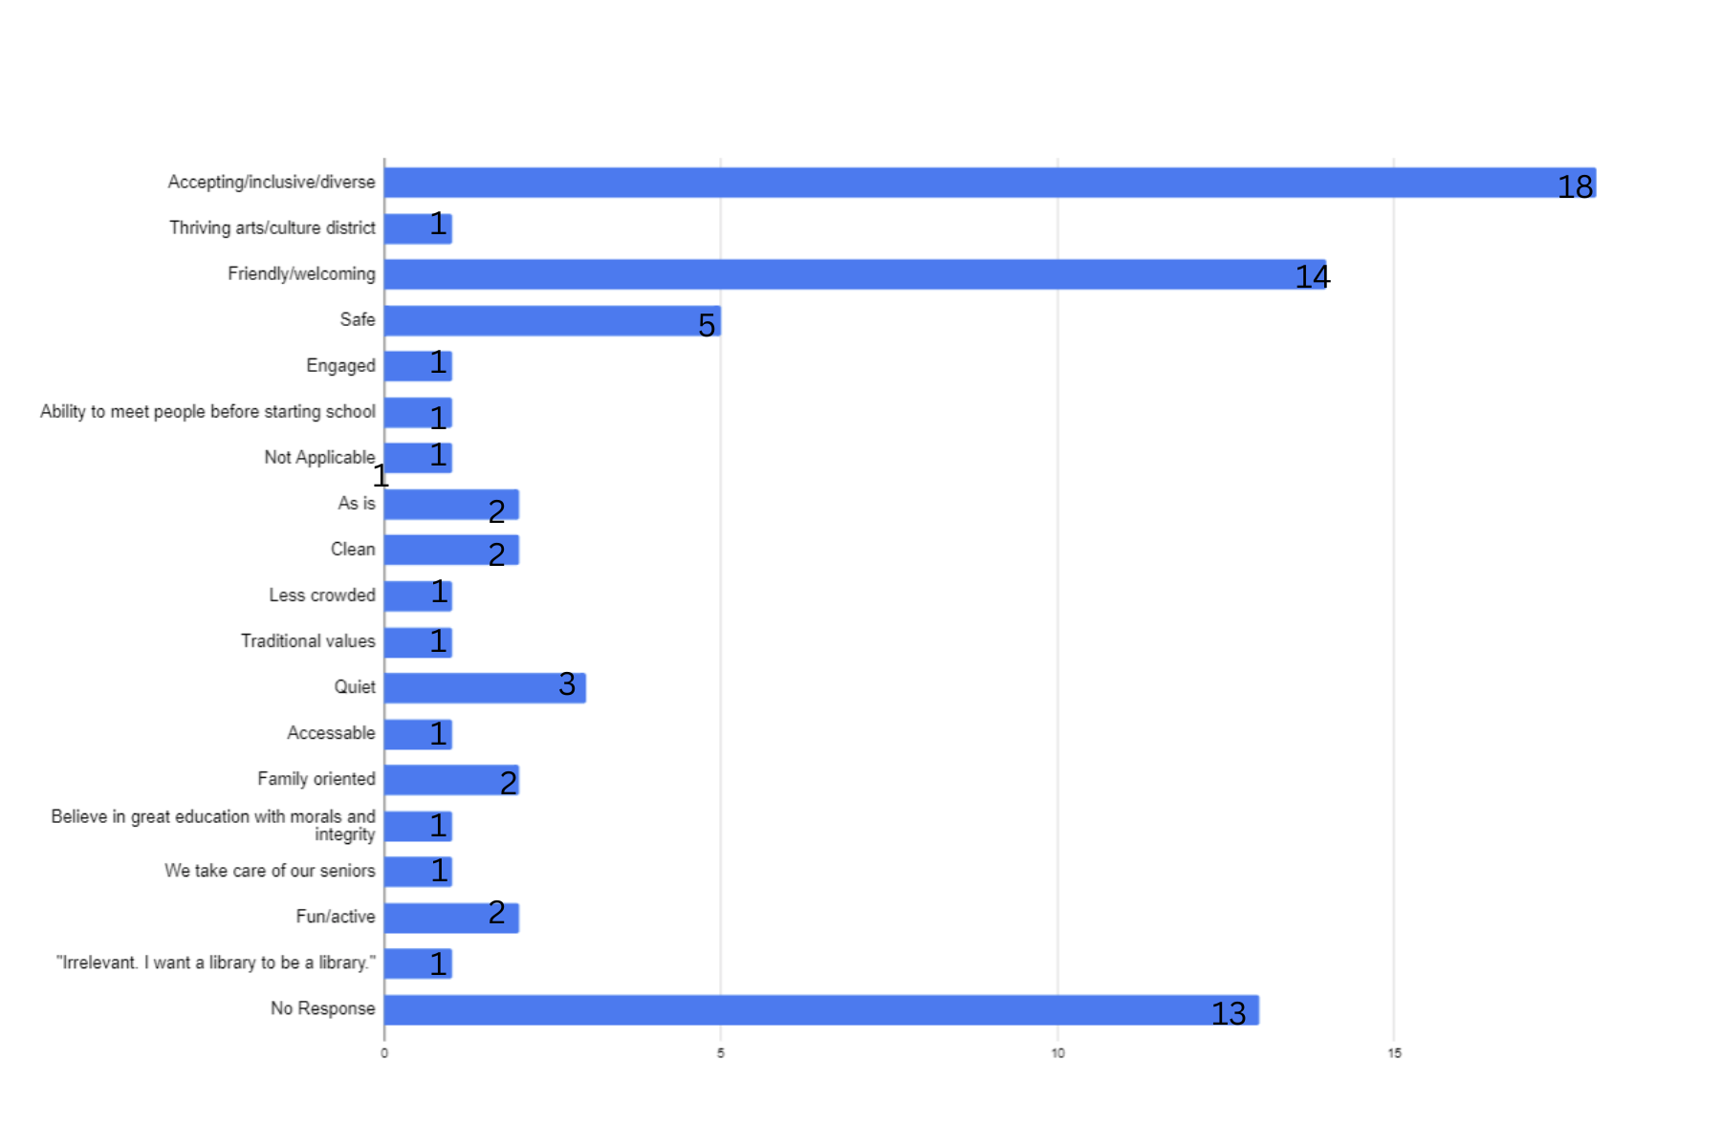

**23. In the past 12 months, have you seen any of the library's marketing/advertising?**

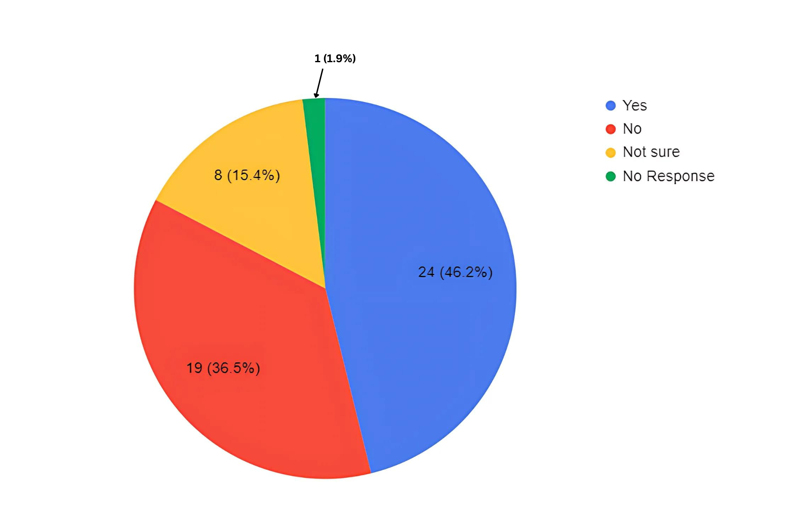

**24. My primary language for reading is:**

* 50 people responded with English as their primary language for reading.
* 2 people did not respond.

**25. Other comments/concerns:**

* “Today was my first time coming to the Lincoln Park Library and I was elated. All the staff were so pleasant and helpful. I also was very impressed witht he many different adult and children programs.”
* “Keep up the good work!!”
* “Thank you for all you guys do!”
* “Perhaps a more interactive summer reading program for children.”
* “Start a book mobile.”
* “Please have friendly staff. Sometimes I feel like I am bothering the staff when I have a question.”
* “Thank you for the survey.”
* “The friendly staff at the front desk. Viv and Janine are always smiling.”
* “Staff is wonderful, space is clean and neatly organized. My family loves coming here.”
* “I like the library and our family uses it frequently. Thank you for keeping the childrens programs interesting and engaging and free from any themes related to politics or adult agendas.”
* “Only fill up half the class the first time it’s put out so that that other have a chance to join in the fun we all don’t see it till it’s to late it all full :( “

**Library responses to some of the common thoughts/suggestions:**

1. While we would have loved to enclose the children’s area to help with the noise, in order to do so, it would have required us to hire 4 or more additional staff members. The salaries for those additional employees would require us to drastically cut back on the number of programs, books and resources we are able to offer the community. It would also require us to close the children’s section if we had nobody to staff it during a particular time. This, along with additional elevator costs, is why we also did not add on an upstairs.
2. As of 9/10/2024 we have the following items available to patrons:

* **71,724** E-books/E- audiobooks
* **2,644** DVDs/Blu Rays
* **25,206** Physical books
* **91** Puzzles (most were donated to us)
* **184** Games (most were donated to us)
* **217** Learning Kits/Memory Care Kits
* **256** Tonies/Yotos (audio books for kids)
* **96** Other Library of Things (including laptops, hotspots, travel accessories and more)
* Museum Passes: Natural History Museum, Historic Sites of Morris County, Montclair Art Museum, Morris Museum, Newark Art Museum

*These numbers change frequently due to new purchases/donations, lost/damaged items, removing items from the system do to lack of checkouts*

1. We are amongst the majority of smaller libraries that have decided to get rid of physical copies of newspapers. We stopped getting physical newspapers in 2020 as it was no longer cost effective for the library. As an example, we were recently quoted over $2,500 for one copy of The New York Times for a year for our patrons. In the past, we would average 2-5 patrons per week that would come in to read our physical papers with many of them only wanting copies of The New York Times crossword puzzle. These newspapers would be recycled at the end of the month, so it is not even something we keep on our shelves for long. However, if someone would like to donate a library subscription of a physical newspaper, we would be happy to accept it and would find a place to have it available.

Even though we do not have physical copies anymore, we do currently have a subscription through Main for the Wall Street Journal. We also, thanks to The Friends of the Library, have an all access online subscription to The New York Times.

1. While we significantly decreased the number of physical magazines that we offer to our patrons in 2023, you can access some additional magazines through Libby. Additionally, we now only keep our magazines for 3 months instead of a full year like we used to pre-Covid. We have decreased the magazine collection over the years since, like the newspapers, we have seen a significant decline in the number of checkouts that they receive.Based on our statistics, magazines are not something that the majority of our patrons are still interested in borrowing from the library.

2020 Magazine checkouts: 238 (Closed End of March- Mid-September due to Covid)

2021 Magazine checkouts: 542

2022 Magazine checkouts: 176

2023 Magazine checkouts: 94

2024 Magazine checkouts (as of 9/10/2024): 83

1. As of September 18, we offered the following number of programs during 2024:

**199** children’s programs

**59** All ages programs

**86** Adult programs

**23** Outreach programs

We had **11,819** participants in these programs.

1. Where do we advertise? We have all of our programs on our website. We also post our programs on Facebook and Instagram. Additionally, both the television in the lobby of the library and behind the circulation desk scroll through all of our programs we have available for the month. Program fliers are sent to the elementary and middle school to be added to the electronic backpack. Additionally, our adult programs are posted on the electronic signs in town hall and in the PAL. Finally, our bigger programs can be found on the town’s electronic sign outside of the library and on channel 77. We also have printouts of the month’s calendar in the front lobby of the library.
2. Adult programs during the day are open to all adults, but are geared towards seniors. We do not label any of our programs for seniors specifically as we don’t want to exclude any adult that isn’t a senior that might want to join. However, seniors may participate in any and all adult and all-ages programming.
3. Program registration is generally posted online the third Wednesday of the month by 5pm for the following month’s activities. Most programs have a waitlist once they are filled. If you want to be added to the waitlist, and can’t do it yourself, please see Alix to be added to the list. Additionally, many of our programs do not require registration to participate.